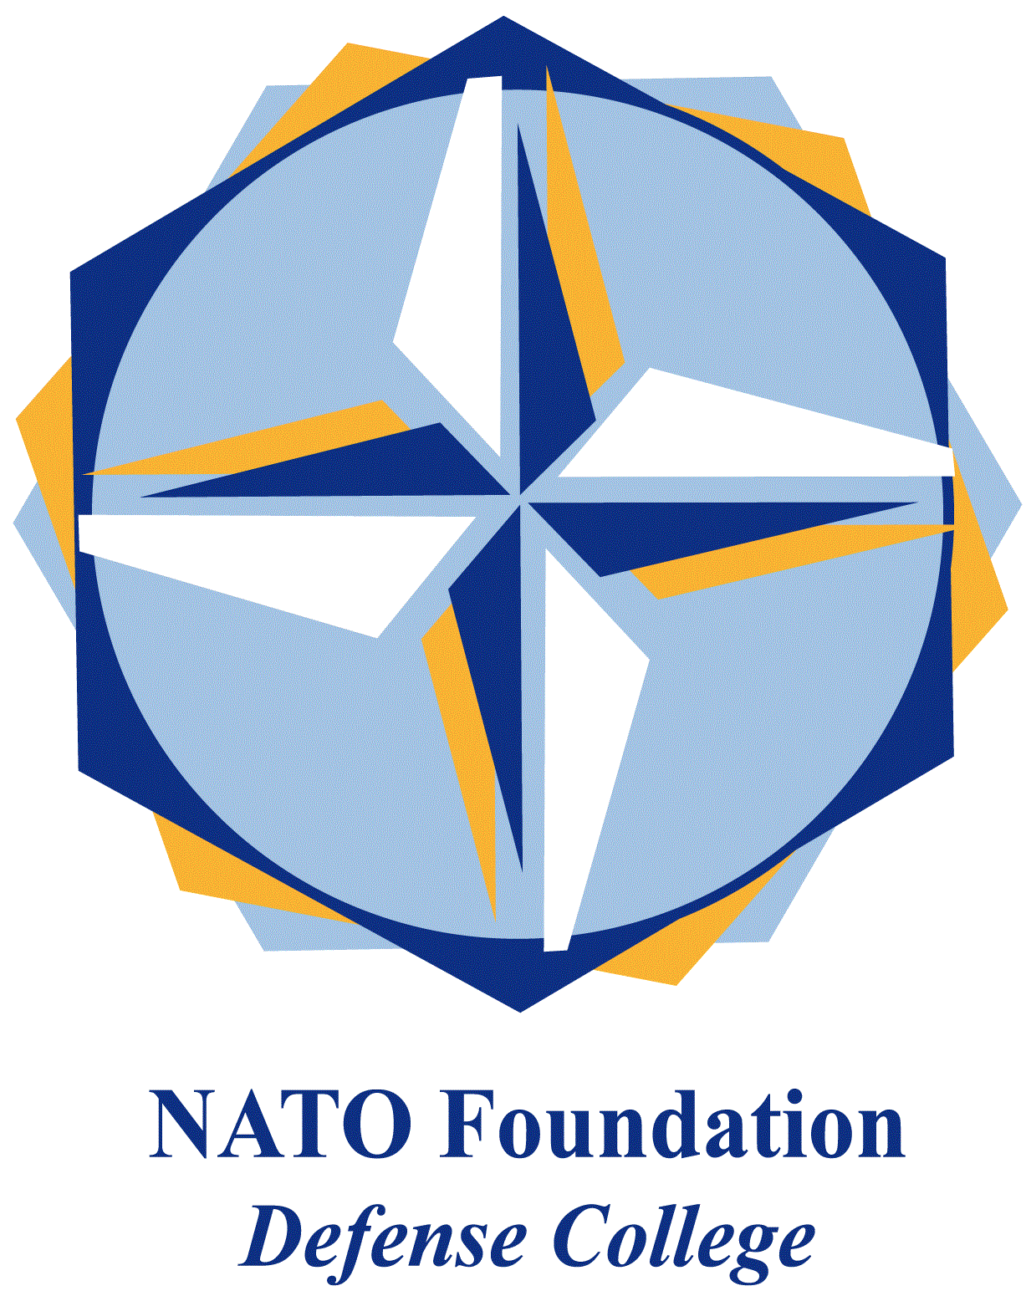

STRATEGIC TRENDS -INDO-PACIFIC April 2019

Manila tilts back towards the USA?

Under Rodrigo Duterte, the Philippines moved from South China Sea confrontation with China, to seek greater economic cooperation. Significant US-Philippine military re-engagement is though now underway.

On the 1st of March, talks with Philippine Foreign Secretary Teodoro Locsin led to US Secretary of State Mike Pompeo commenting “China’s island building and military activities in the South China Sea threaten Philippine sovereignty, security and therefore economic livelihood, as well as that of the United States”; and that “any armed attack on Philippine forces, aircraft or public vessels in the South China Sea will trigger mutual defense obligations under Article 4 of our mutual defense treaty”.

On the 1st of April, talks between the US Defense Secretary Patrick Shanahan and his Philippine counterpart Delfin Lorenzana stressed interoperability between the two militaries, which the Pentagon noted was “advancing our vision for a free and open Indo-Pacific”.

From the 1st-12th April, the US-Philippine Balikatan 2019 exercise, for the first time included the amphibious assault ship USS Wasp decked with Marine Corps F-35B aircraft. Their mission was implicitly China-related, since the tactical theme was recapturing small islands occupied by unnamed forces. China’s Foreign Ministry warned on the 12th of April that USS Wasp’s deployment reflected “non-regional states stirring up trouble in the calm waters of the South China Sea”.

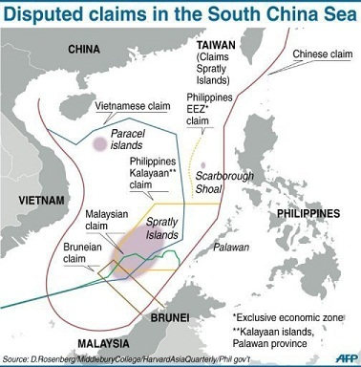

Meanwhile, since January China deployed large scale fishing and militia boat incursions around Philippine forces at Pag-asa (Thitu), the Philippines’ largest possession which China also claims. Initially sparked by Philippine plans to strengthen its Pag-asa facilities, there was a further Chinese surge during the Balikatan 2019 exercises. On the 4th of April the Philippine Foreign Ministry denounced Beijing’s “coercive objectives”, and argued that the massed “presence of Chinese vessels near and around Pag-asa and other maritime features in the KIG [Kalayaan Island Group] is illegal. Such actions are a clear violation of Philippine sovereignty, sovereign rights and jurisdiction”. Demonstrations were held on the 9th of April outside the Chinese embassy in Manila.

Three developments are apparent. First, on the 15th of April Duterte denounced Chinese actions and in a new move stated that the 2016 Permanent Court of Arbitration (PCA) ruling on the South China Sea, brought by the previous administration, which had found against China, would now be re-invoked at some point. On the other hand Manila is very cautious in disrupting the development investments flow from China.

Second, discussions were held on introducing a US High Mobility Artillery Rocket System (HIMARS) into the Philippines, capable of launching precision-guided rockets at Chinese positions on the Spratly Islands.

Third, discussions on renewing the US-Philippine Mutual Defense Treaty accelerated, to extend its sway more formally into the South China Sea. In the South China Sea, China’s position may have weakened and the US position has re-strengthened.
David Scott – Researcher and guest lecturer at various academic and military institutions, specialising in contemporary East-West relations and the Indo-Pacific area.

